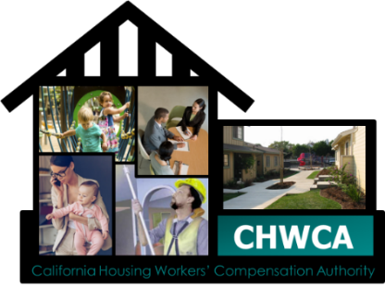

2023 safety award program APPLICATION

Do you have an idea about how to keep you and your fellow employees safe at work?
If so, the CHWCA Risk Management Committee would like to hear about your safety ideas and solutions. The Cash for Culture Safety Award Program was established by the CHWCA Risk Management Committee to promote a positive safety culture by recognizing and rewarding employees and agencies who take an active role in their agency’s safety program.
Agencies may be rewarded for implementing proactive/innovative safety solutions that impact workplace safety.
Employees may be rewarded for:
- Recognizing hazards and developing solutions to improve the workplace
- Developing solutions to prevent close calls or accidents from happening again
- Submitting ideas to improve safety programs that get implemented
Employee Awards: | Agency Awards:
Most Oustanding Suggestion - $500 (one award) | Most Outstanding Suggestion - $6,000 (one award)
Outstanding Suggestion - $250 ( five awards) | Outstanding Suggestion - $3,000 (one award)
Good Suggestion - $100 (multiple awards) | Honorable Mention - Certificate
Honorable Mentions - Certificate

One monetary award per employee/agency.
Submit your ideas and solutions by completing the form below and email to Jane Hayes at jane.hayes@sedgwick.com. We encourage you to submit your ideas and solutions as they arise. Use a separate Application Form for each submission.
All submissions must be received by October 31, 2023 in order to be eligble. Employee submissions must have your manager’s approval.
Talk to your manager for additional information, or call Jane Hayes at 916.899.8831 or Ignacio Barrios at 626.230.4635.
Retain a copy of all documents for your records. Once we receive your submission, a confirmation email will be sent to your manager.

2023 CHWCA Safety Award Program Application
Agency Name: |  |  |  |  | Department:
Employee Name: |  |  | Email: |  |  |  | Phone #
Manager Name: |  |  | Email: |  |  |  | Phone #
Employee Submission ☐ Agency Submission ☐
Describe the hazard or problem:
Provide details about your idea and solutions:
Describe the results:
Attach additional details and supporting documentation if needed.

Employee Signature |  |  |  | Manager Signature

